


The Jewish Vocational School Masada in Darmstadt


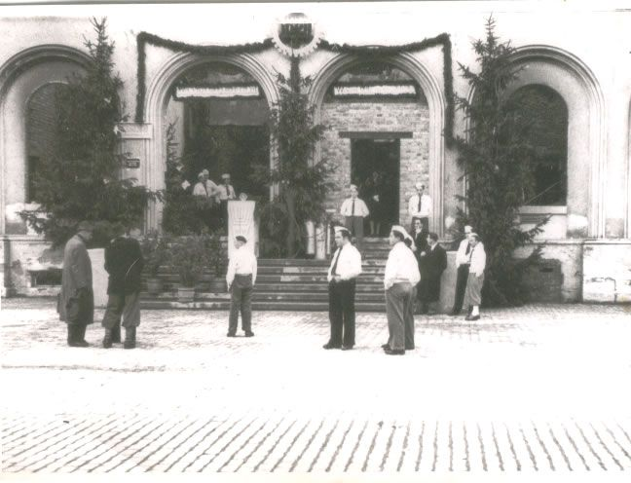
Samuel Milek Batalion established and directed the Jewish Vocational School Masada during the years 1947 and 1948. Moshe Mordchelewitz, the Madrich in the school assisted him.

In the School were youngsters from DP camps in Germany. They were trained to be carpenters, locksmith, electricians and other trades. These professions were thought to be necessary for the establishment of a Kibbutz in Eretz Israel. The Madrich taught the students Hebrew, Jewish Philosophy, physical fitness, Betar and Zionist ideology.

The Jewish vocational school was in many ways exceptional.
Opening Ceremony of the School
The school occupied an old almost destroyed train station building in the center of the city Darmstadt in contrast to most all of the Jewish schools in the after war period which were located within the DP camps.
It was a Betar school, which was directed by a private person: Samuel Milek Batalion. He organized the teaching and living facilities, the food provision, teaching staff and equipment for the school
Even though the existed only for 10 month, it is an important part of the after-war history of Hesse and an expression of the renewed Jewish life in
Germany.
Today, more than 60 years after the existence of the school, Batalion,'s daughter Lea Dror-Batalion in the middle of a research project to reconstruct the history of the school.
The findings of the research project can be here with a list of former students and teachers.
The Exhibition
There will be an exhibition on January 27, 2011 in the
Heinrich-Emanuel-Merck-School (HEMS) vocational school in Darmstadt.
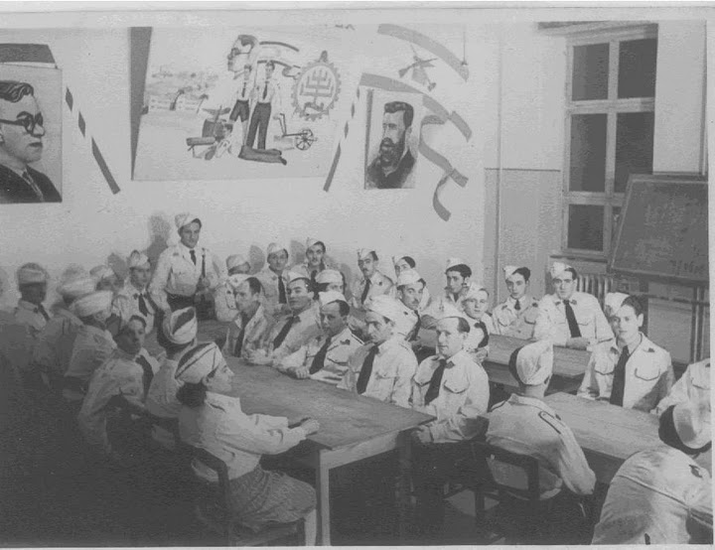
The exhibition is a combined project of Lea Dror-Batalion
Renate Dreesen and the students
of the HEMS.
The exhibition will be in three languages since will travel to Israel.
It will also be shown in additional cities in Germany.

A small extract of the exhibition can be seen from Sept. 8, 2010 at the state social court exhibition "Steubenplatz–Standort – Standpunkteim" at the Steubenplatz in Darmstadt, Betar Training
the former location of the train station.

We are searching for Witnesses

We are looking for witness, who can recall any details about the school, who we in touch with the school as teachers or suppliers or government officials.

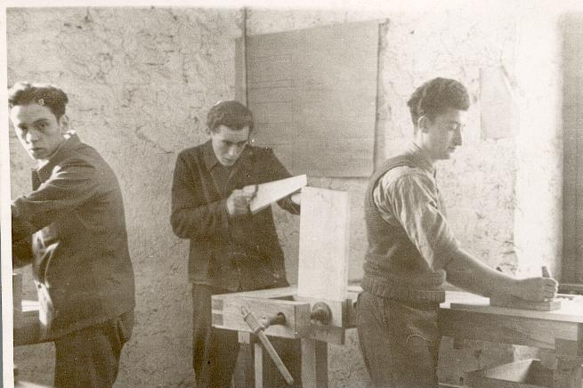
If you were a student at the Jewish vocational school or are a family member of any of the former student or teacher or if you have any information about the school, please contact Lea Dror-Batalion in Israel (E-Mail ldror@batalion.net or Tel. 04-8288232) or Renate Dreesen in Darmstadt (rdreesen@gmx.net or Tel. 06157-84470).

Workshop
in the School

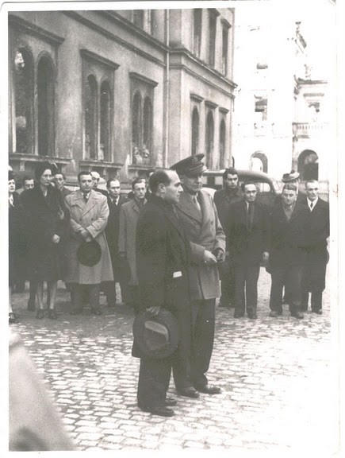

Please support the Project through Contribution

The preparations and realization of the
exhibition is costly. We are asking for
financial support. We can provide a receipt.

Contact Information:
Renate Dreesen, Adam-Schwinn-Str. 49
64319 Pfungstadt, 06157/84470,
rdreesen@gmx.net
Supported by: INITIATIVE „GEDENKORT GÜTERBAHNHOF DARMSTADT
Arbeitskreis ehemalige Synagoge,Pfungstadt e.V. and others
Photo of the opening ceremony of the school
5.12.1947. Dr. Aron Propes, Betar Youth USA
Colonel Rose, American Military Government

